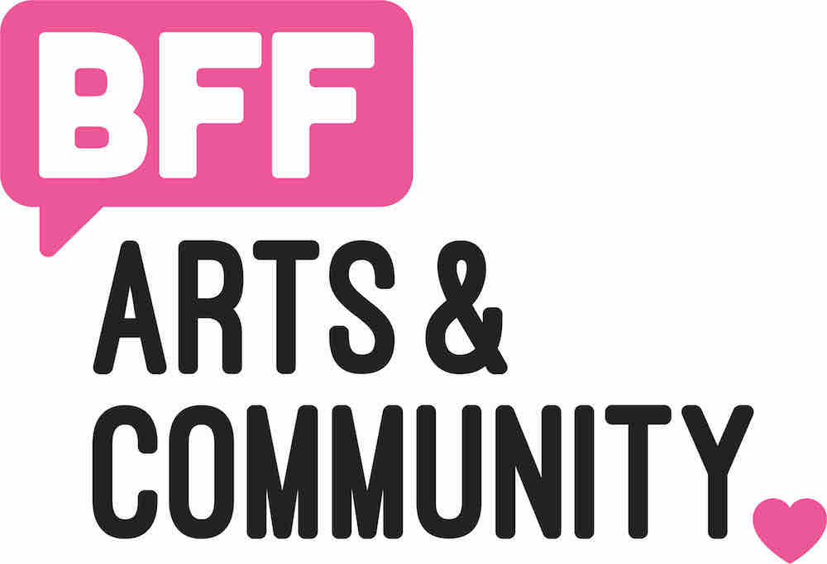

FOR IMMEDIATE RELEASE
July 10, 2019

Contact: Alex Jochim, alex@bffomaha.org

BFF’s Mobile Art Gallery in Downtown, Sacred Seed Community Art Project

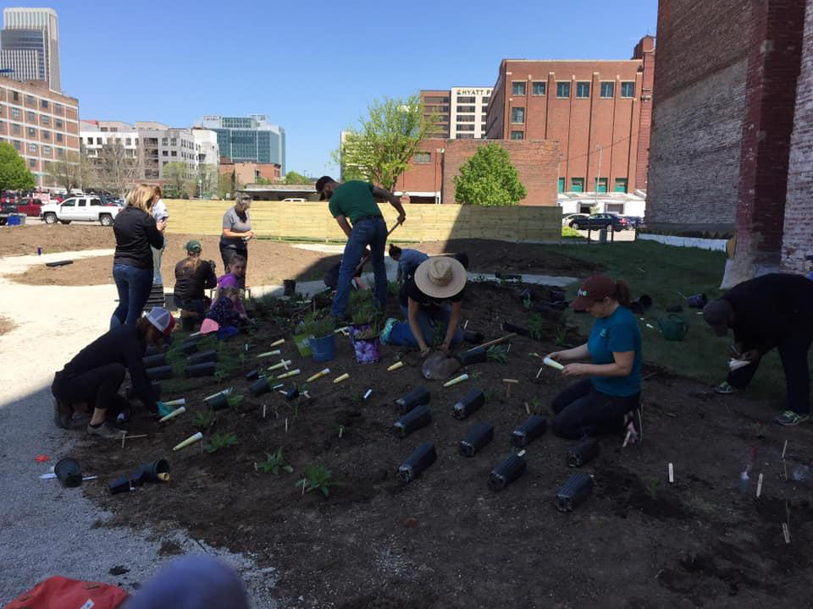
Photo Credit, Sacred Seed Pop-Up

BFF and Sacred Seed Pop-Up are collaborating on a community art project in Downtown Omaha, 727 South 13th Street. The community is invited to submit their favorite nature photo that they’ve taken (all skill levels are welcome!) to sacredseedpopup@gmail.com. Submissions accepted through July 12th. Sacred Seed Pop-Up will print all of the community’s photographs and display them inside of BFF’s Mayflower Mobile Gallery (MaMO).

The Community Group Exhibition will then be on display July 16 - 25th. The gallery will be open to the public anytime a Sacred Seed Pop-Up team member is present. You can keep up to date on the Facebook page event.

About BFF
BFF is dedicated to supporting the region’s emerging and established artists by creating opportunity, exposure, and experiences that help them move forward while enriching the cultural competency of the Greater Omaha Area.

About Sacred Seed Pop-Up
The Sacred Seed Pop-Up is a community green space in downtown Omaha - part garden, part prairie, part art installation, and part gathering space. People living and working together in Omaha collaborated to produce this space.

