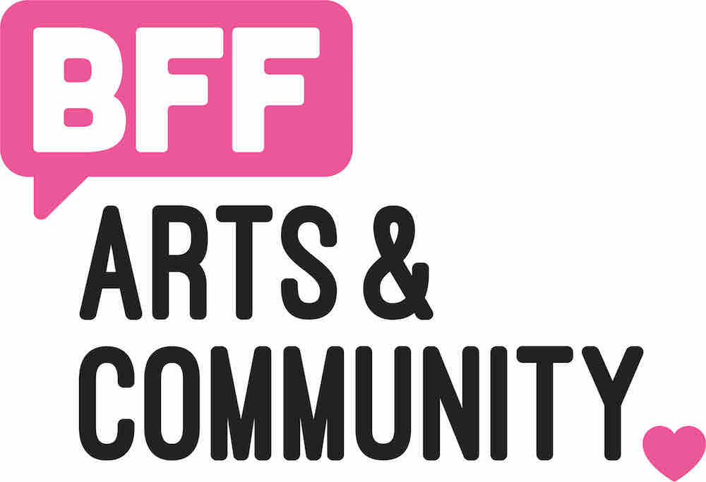
FOR IMMEDIATE RELEASE
July 19, 2019

Contact: Alex Jochim, alex@bffomaha.org

July 27, Pack Your Beach Bags for BFF’s Benson Beach at Benson Days 2019

Pack your beach bags and head to Military Avenue and Maple Street next weekend where you can dive head first into BFF’s Benson BEACH, one of the many festivities at Benson Days, July 27th. Benson Days is a family friendly summer festival that celebrates the Benson neighborhood’s creative culture starting with a parade hosted by the very talented Caitlin Little and Tony Buttells. Visitors to BFF’s Benson BEACH can expect surf rock, beach balls, baby pools, youth activities and community art projects!
Don’t worry adults, Benson Days is for you, too! Benson Days, sponsored by the Benson Neighborhood Association, is a full street celebration with vendors, art, live music, and activities, all with a beer garden a few steps away.

Schedule of events:
8 am - 10:30 am: Pancake Feed
10 am: PARADE
10 am - 4 pm: Street Festival
11:30 am: Mural Tour with Maggie Weber, BFF’s Public Art Director
12 pm - 10 pm: Beer Garden
Bands in the Beer Garden! ALL AGES (12-7pm) and 21+ (7pm-12am)

On the other side of Benson, BFF’s mobile art gallery, the MaMO, will be parked in front of Ted & Wally’s Ice Cream Shop. Visit the MaMO and experience the Cirque Renouvele Exhibition by local artist, Anthony Deon Brown. The mobile gallery will be be open all weekend, so those who are attending the Sunday 10K/5K Race, the Indie at Benson Days, can also experience the spectacular work inspired by the mystery of classical French performances, aesthetic, and backstage design.

Thank you, Douglas County, Nebraska the Nebraska Arts Council and the Nebraska Cultural Endowment for the support of the Mayflower Mobile Gallery (MaMO).
Artwork by Anthony Deon Brown,
on display in BFF’s Mayflower Mobile Gallery (MaMO)

About BFF
BFF is dedicated to supporting the region’s emerging and established artists by creating opportunity, exposure, and experiences that help them move forward while enriching the cultural competency of the Greater Omaha Area.

